Towing Guide

Broken Compass Roleplay
v1

How to Get the Job
You can get the job at the City Services counter. If you don’t have a vehicle you can /taxi and have it take you to the GPS marker you have. The marker is a white shield seen below.
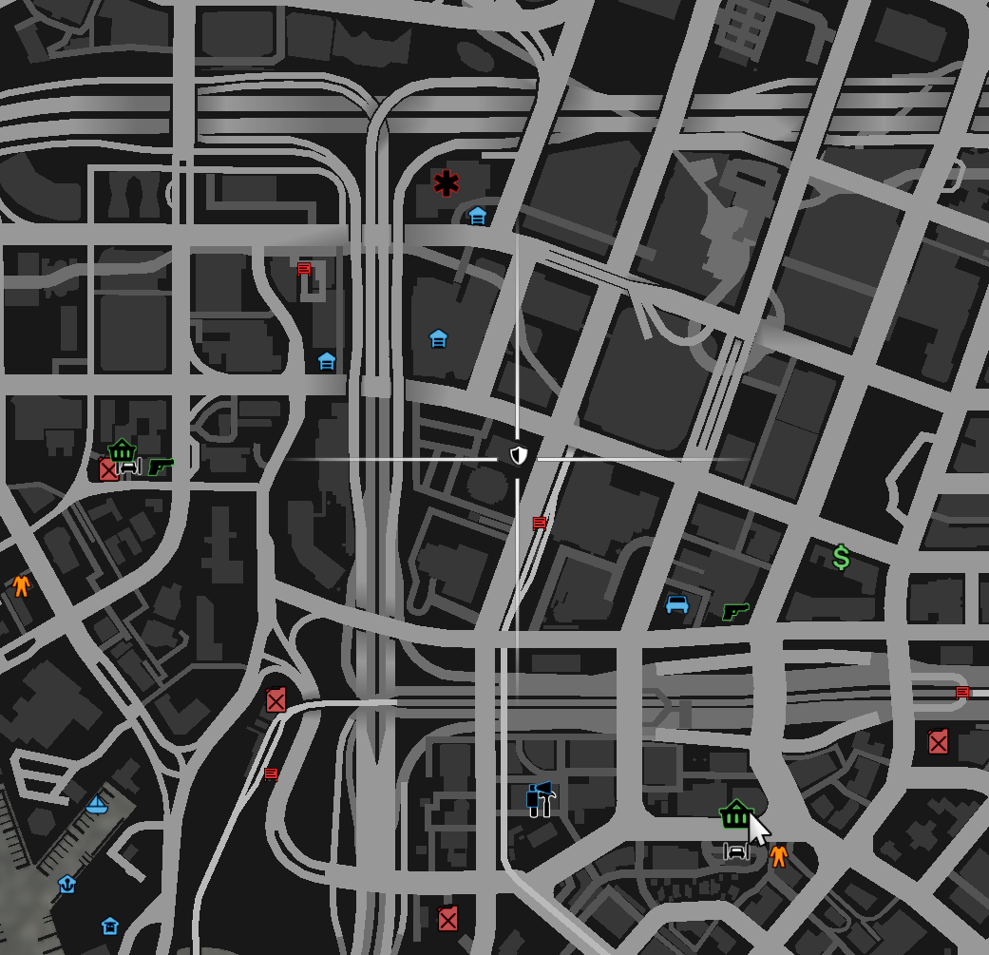

You can always get the job back by coming here should you lose it somehow.

Getting to the Job Area
You can also use /taxi to take you to the job area. You’ll find the job set up around Los Customs near the airport south of the City Services counter and Vesucci Proper.
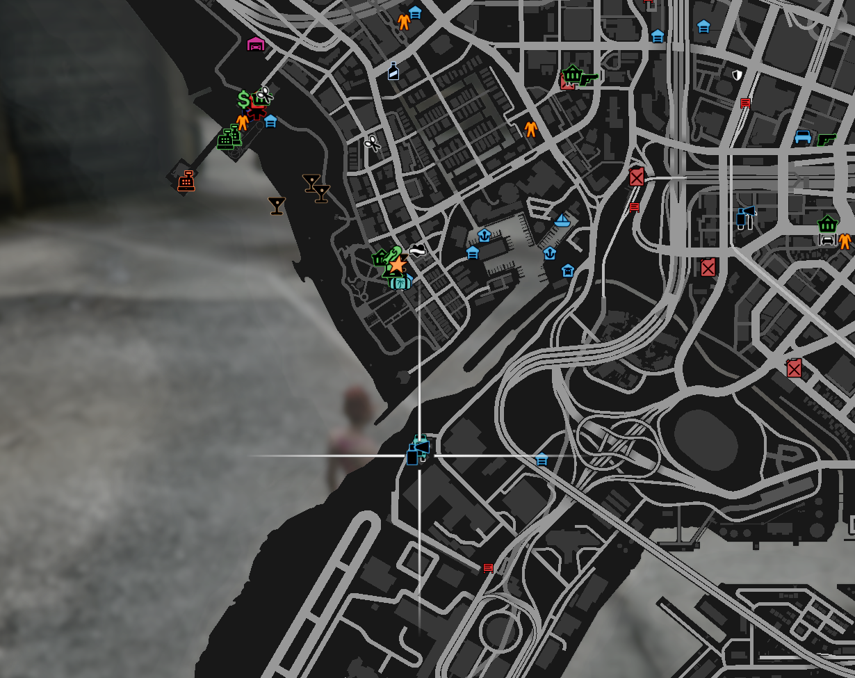
There is also a Los Customs shop set up for people to customize their vehicle there as well as a crafting bench.

Getting a Job Vehicle
The job’s vehicle can be obtained by walking to the red arrow. It only appears when you get closer. Once you are close enough a menu will appear. The Flatbed Tow Truck seems to be the easiest to use.
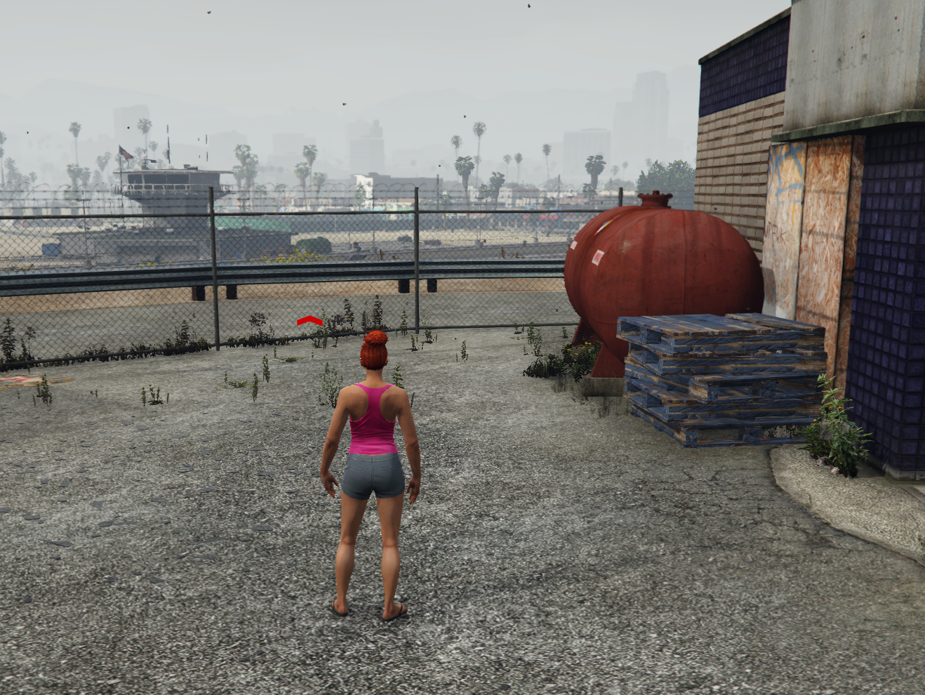
! - You also return your truck here too.

Getting Paid!
To get paid out approach the blue office door inside the Los Customs Shop. It will automatically pay for however many vehicles you have towed.
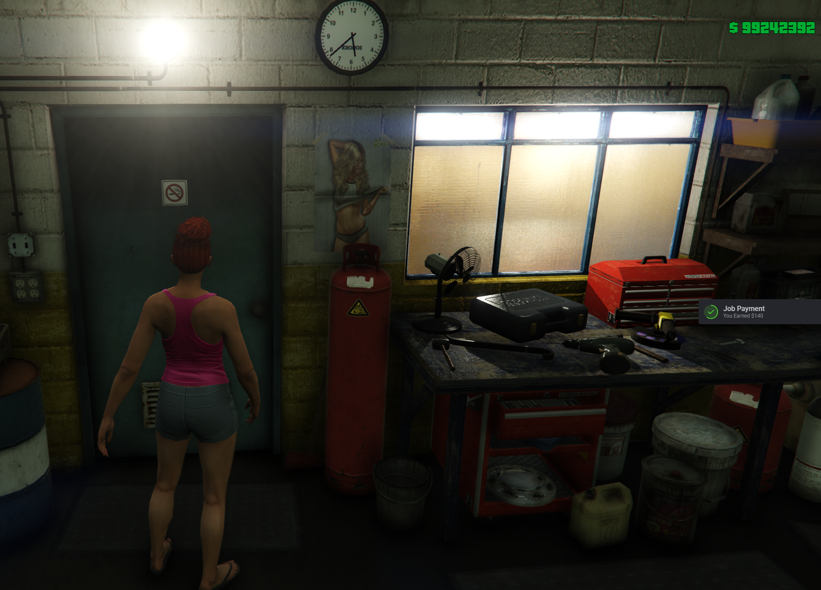

Doing The Job
To start towing vehicles you can hold Z for the radial menu, choose Job, then Toggle NPC.
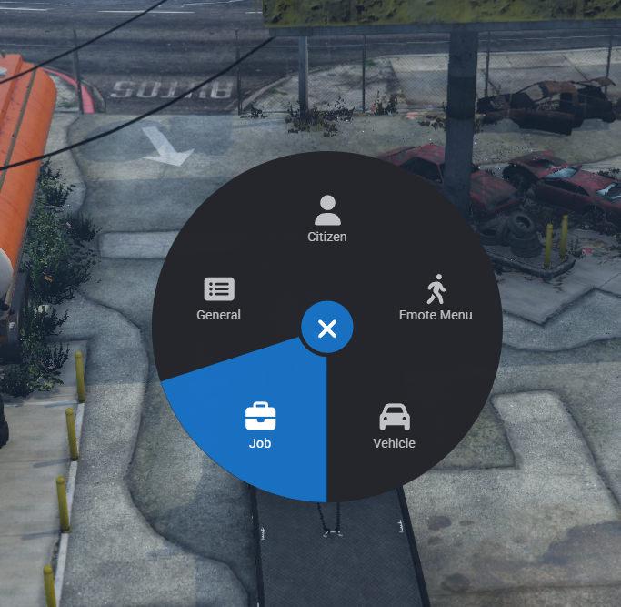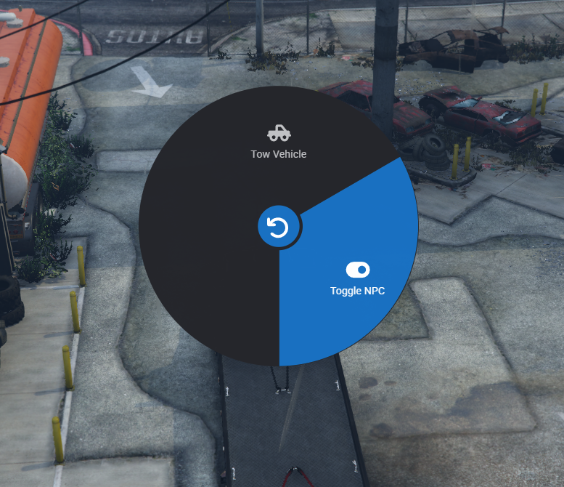

Finding the Vehicle to Tow.
The game will automatically mark your map with a GPS and route. Simply follow it to the vehicle.
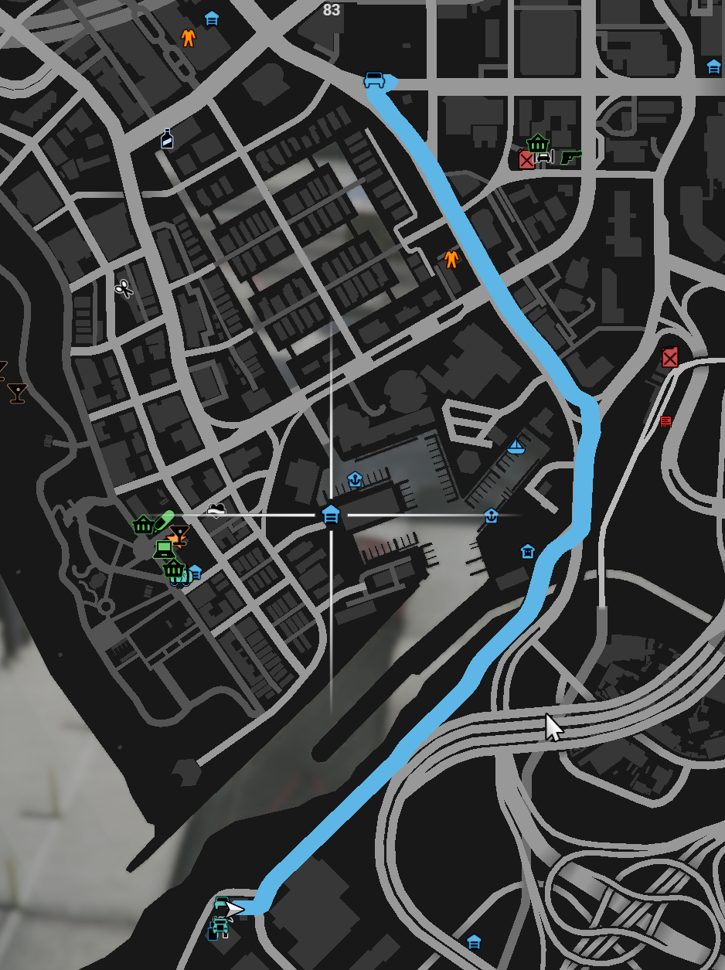

Towing the Vehicle
As you approach where the vehicle is supposed to be it will appear. Pull near it and use with the radial menu to tow it or /tow. If you get an error sometimes a little love tap will resolve the error.
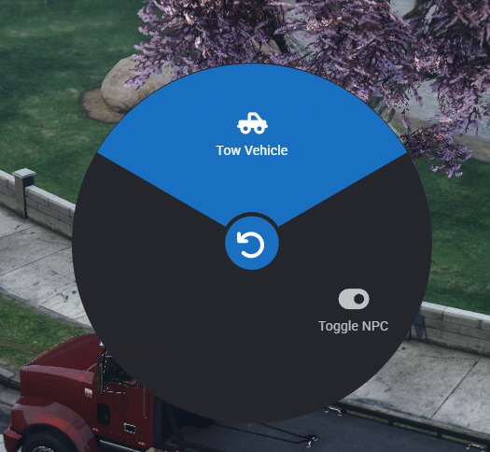
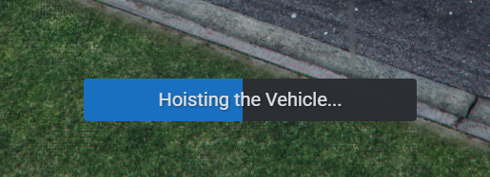
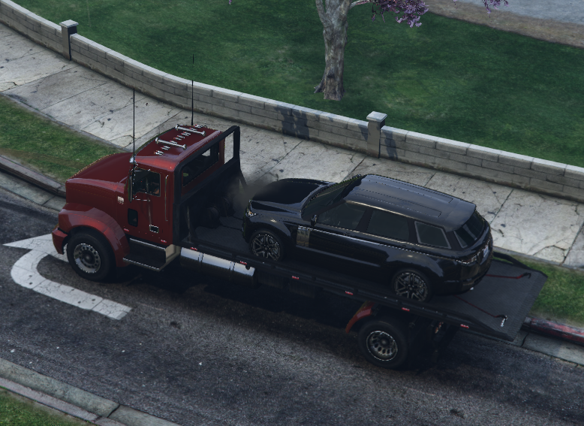

Bring the Vehicle to the Drop Off
Once you have gotten the vehicle on the truck you return to the tow lot and you can use the radial menu by holding Z > Job > Tow Vehicle or /tow to release the vehicle near the red arrow.
